Saveetha Complier Programs
Name: K.Niharika
Reg No: 192411124

1.STR to INT
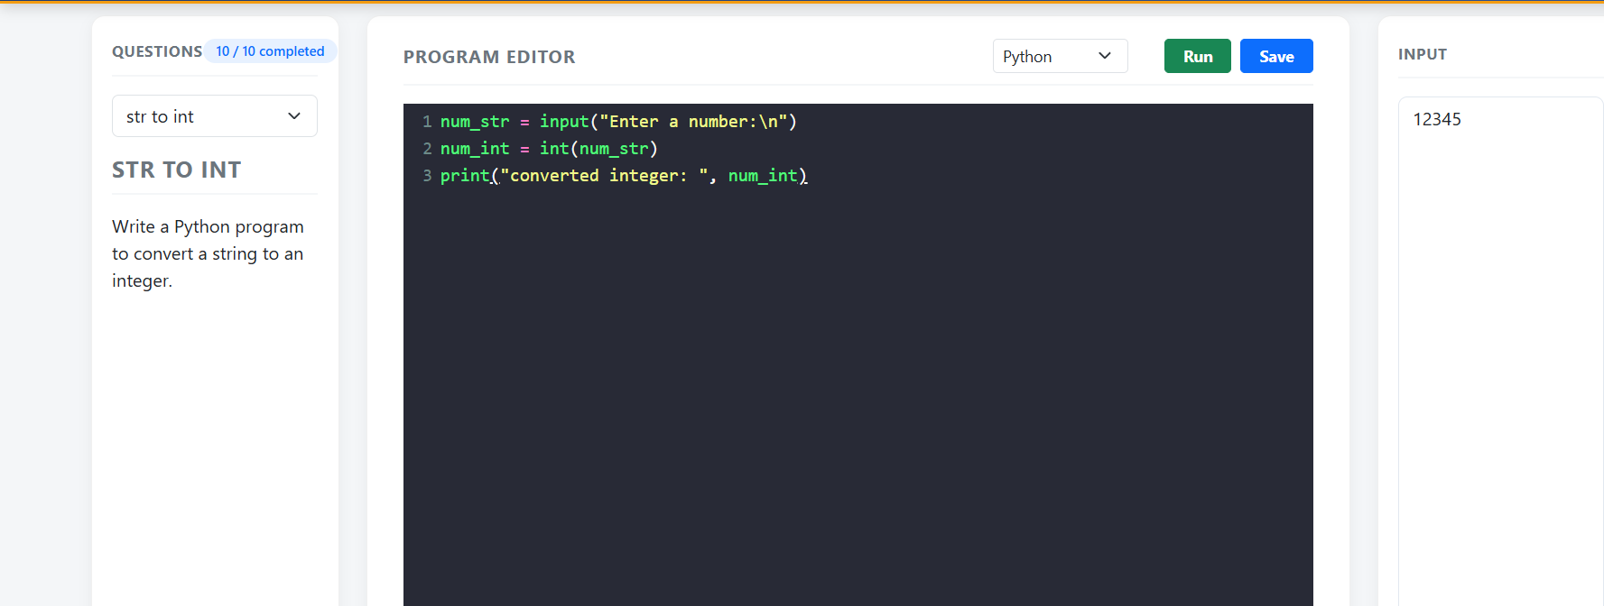

- STR to FLOAT
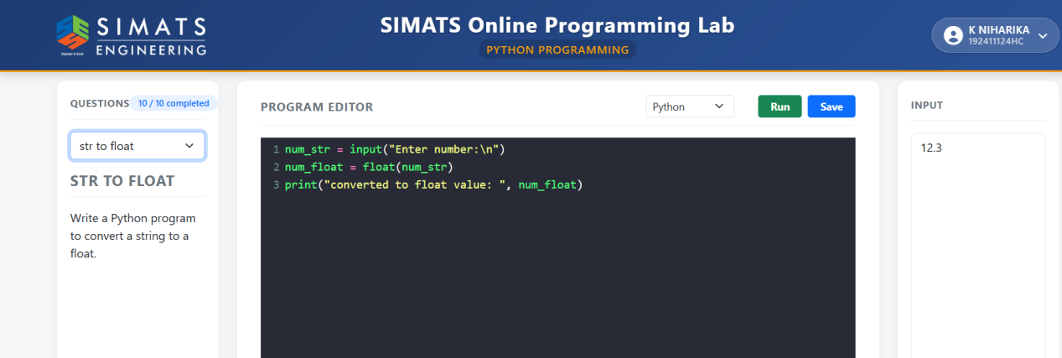

- LIST to TUPLE

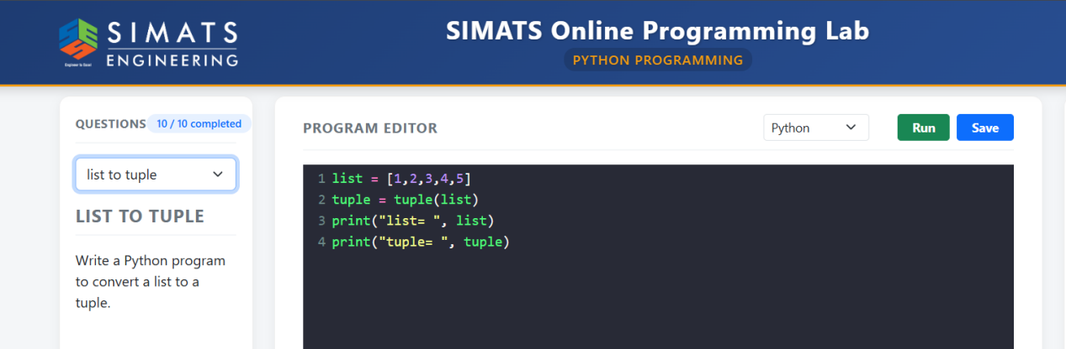

4.TUPLE to LIST

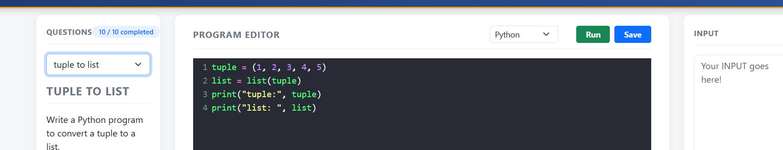

5.Factorial
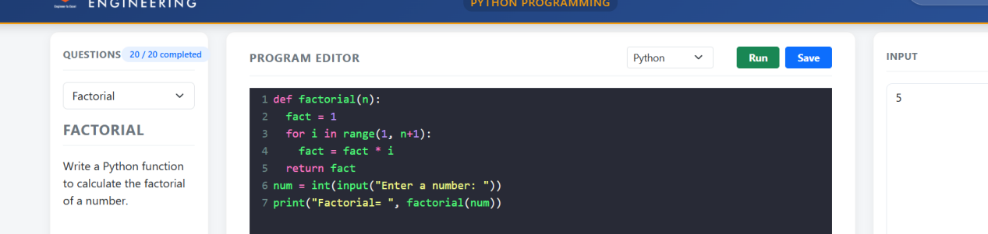

- MAX

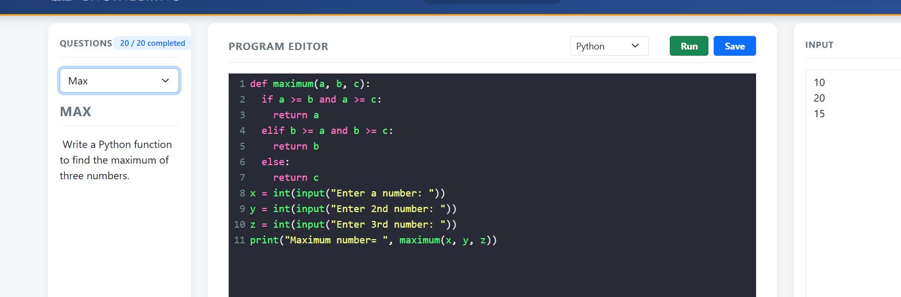

7.Palindrome

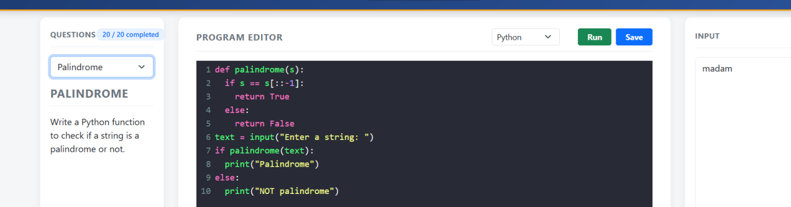

- Area

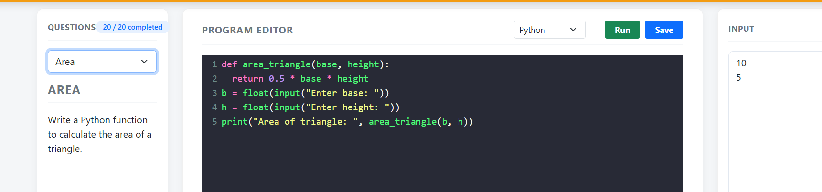

- Count vowels

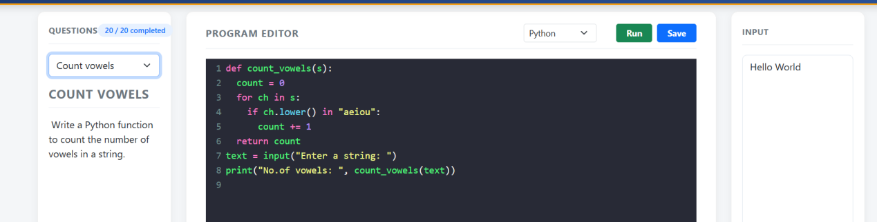
9.Odd or even

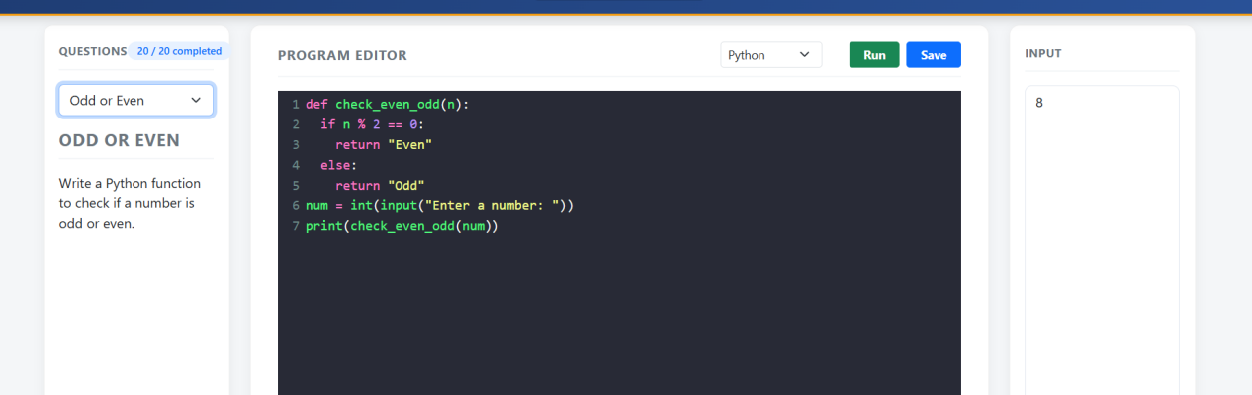

10.Reverse string

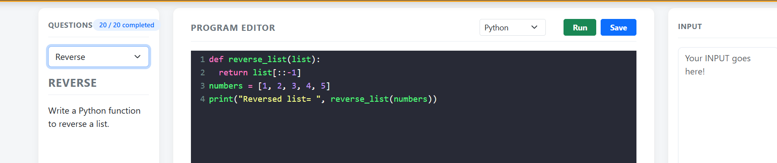

11.Prime or not

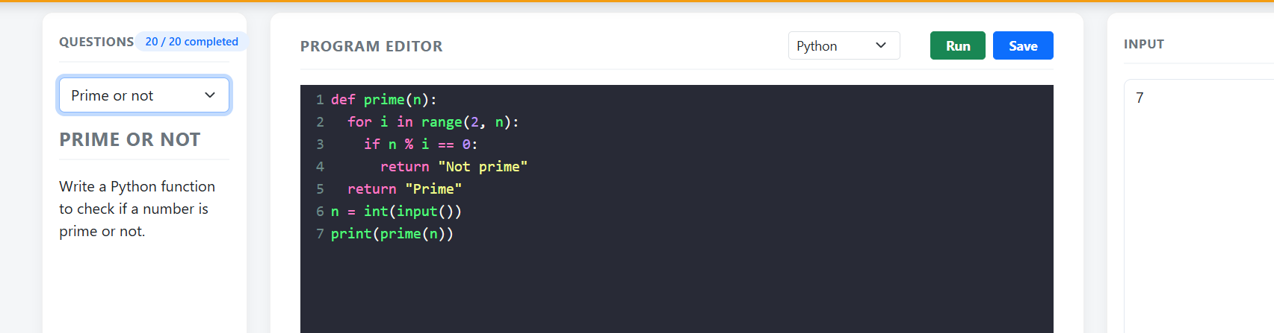

12.Ascending order

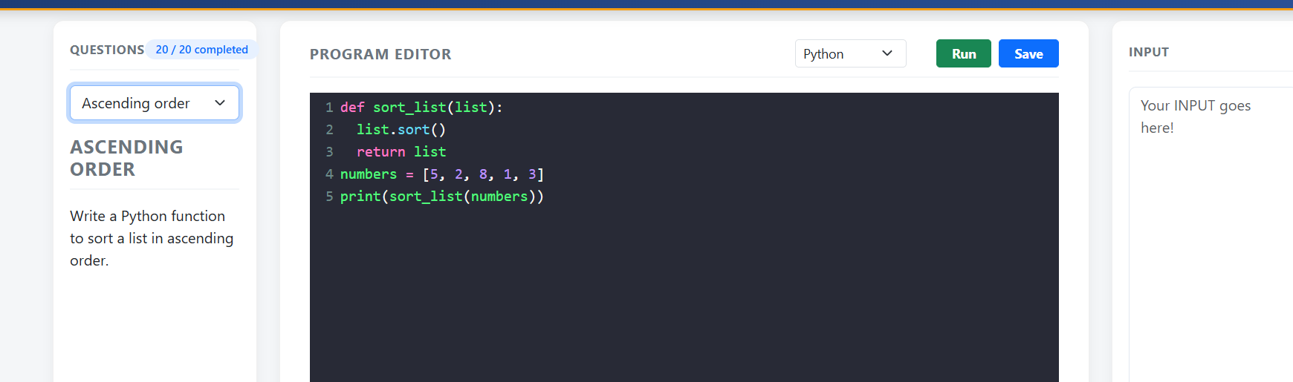

13.Remove duplicates
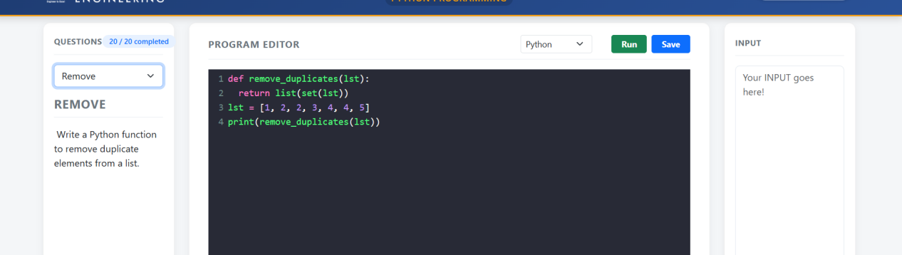

14.Sum of digits

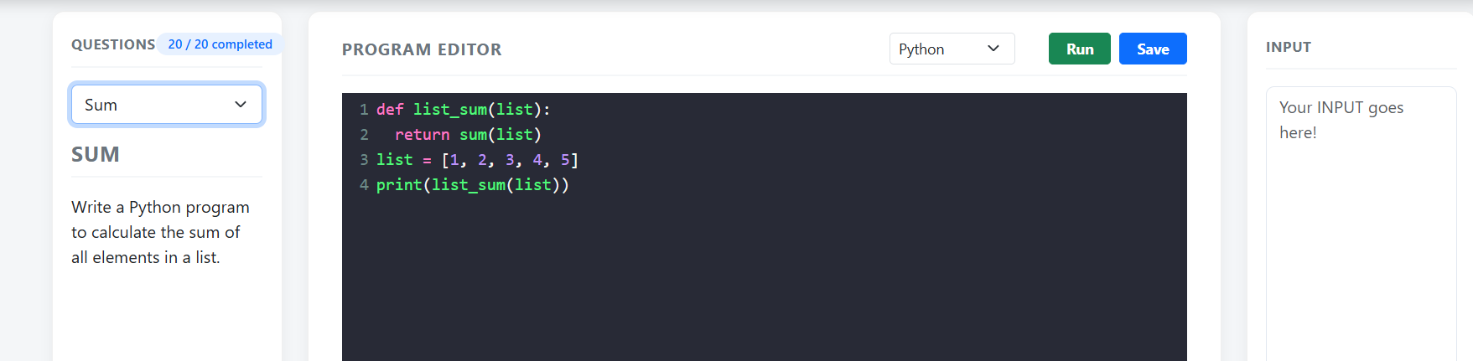

15.2ndmax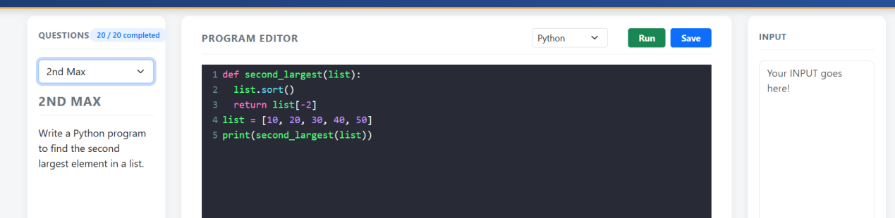

16.GCD
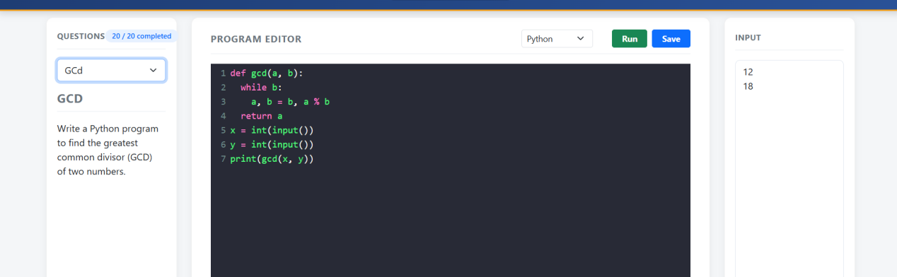

17.LCM

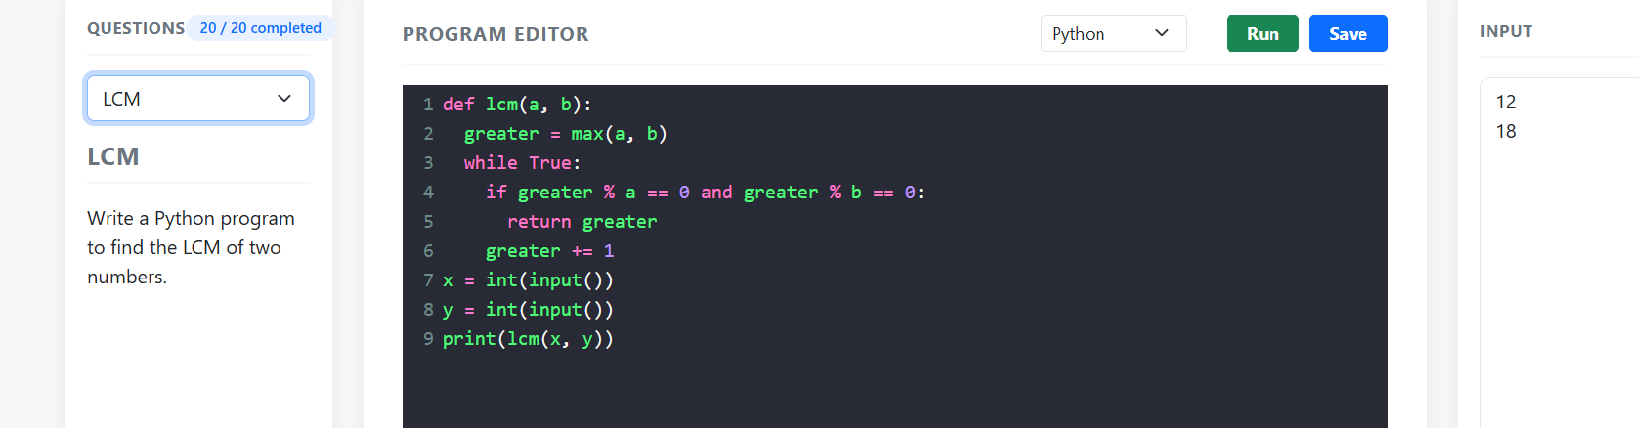

18.Newton-Raphson

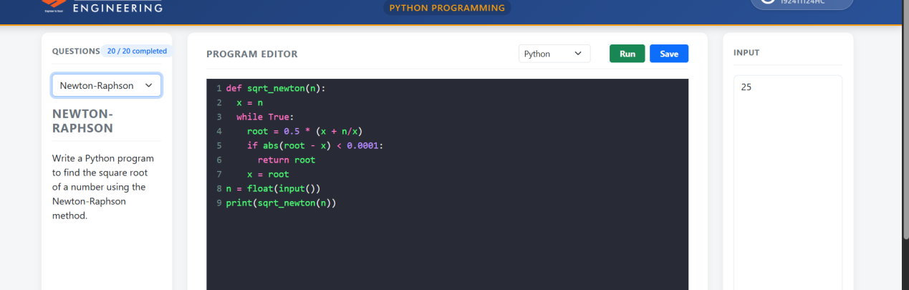
19.N Natural

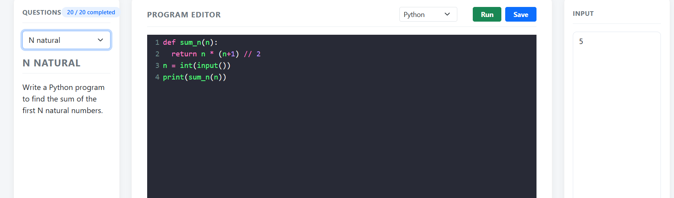

20.Arithmetic

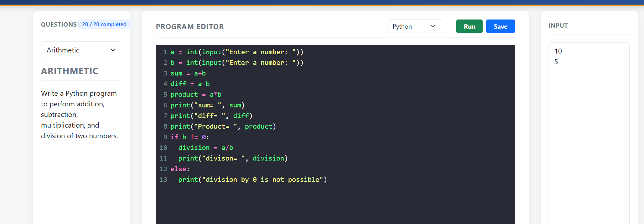

- Modulus

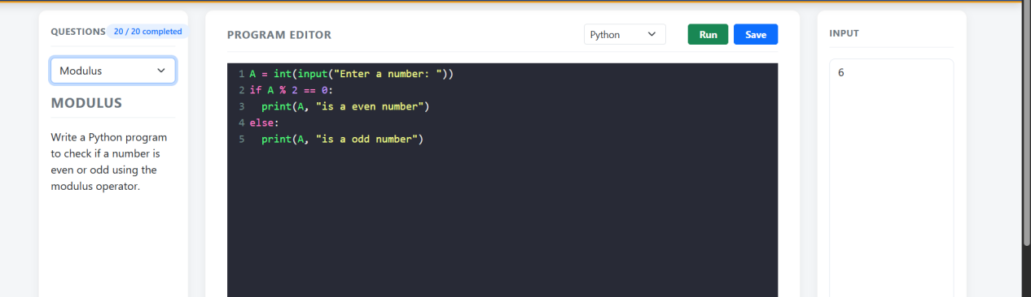

22.Comparison

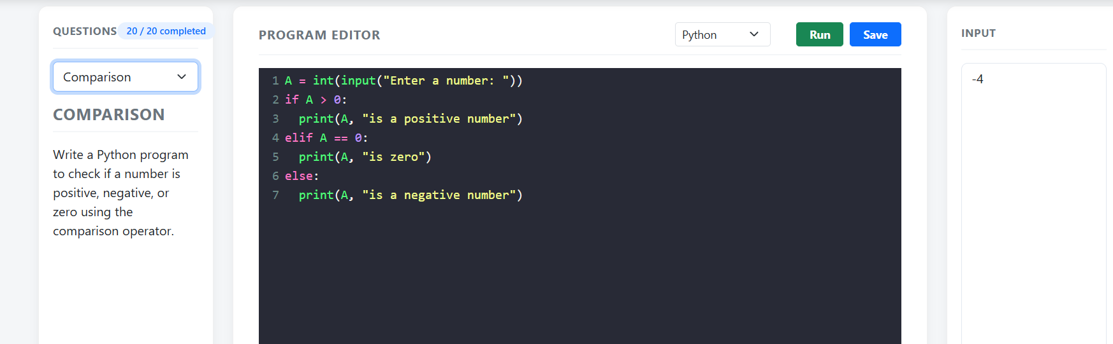

23.Assignment

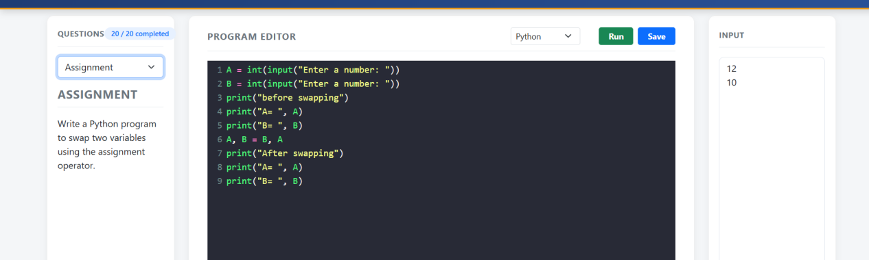

24.Concatenation

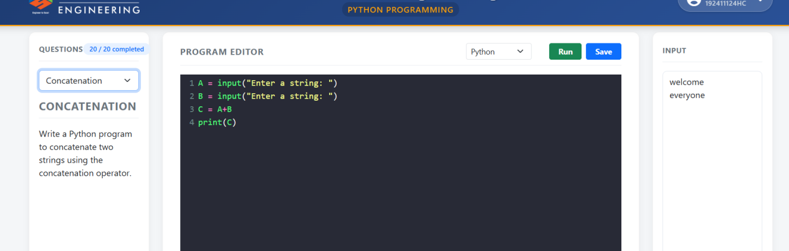

- Modulus

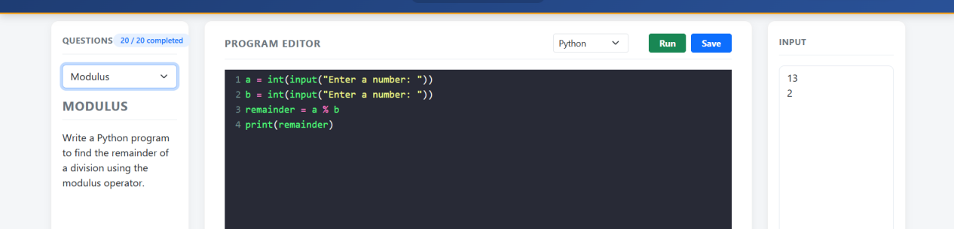

26.Logical operations

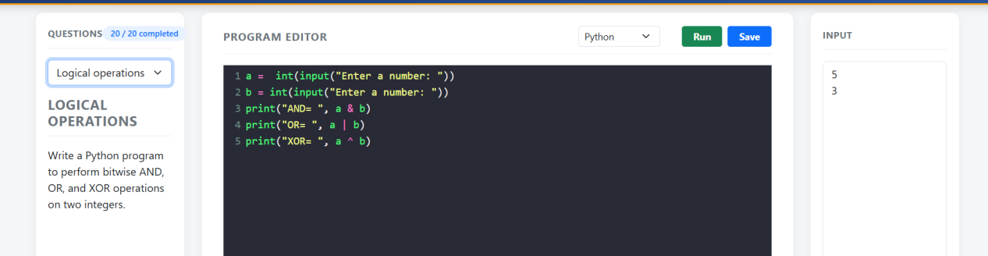

27.Bitwise operator
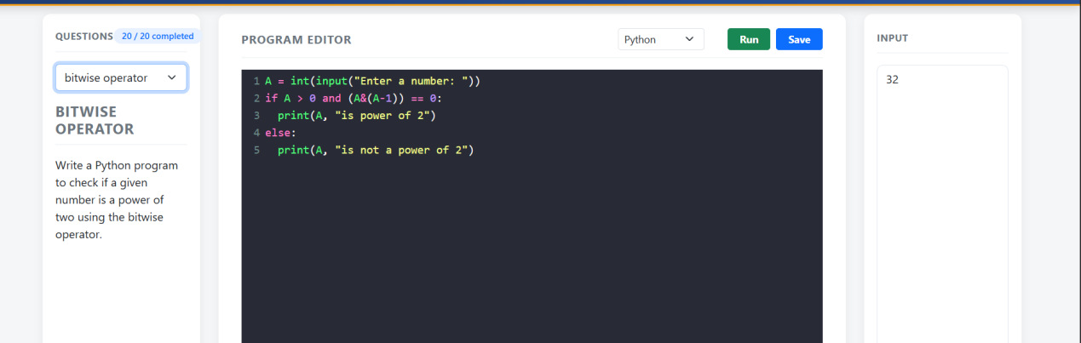

28.Shift operators

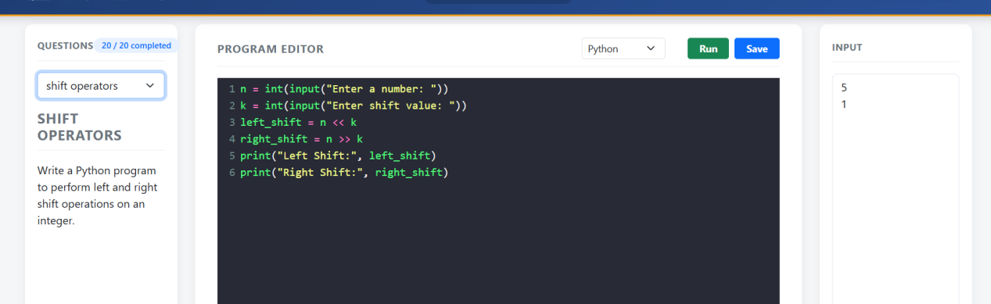

29.Ternary operator
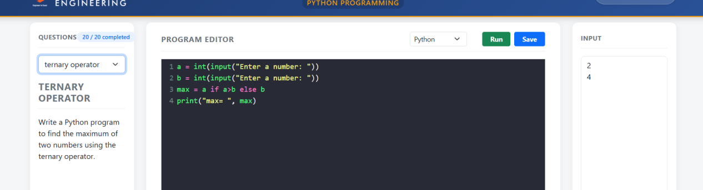

30.Area of rectangle
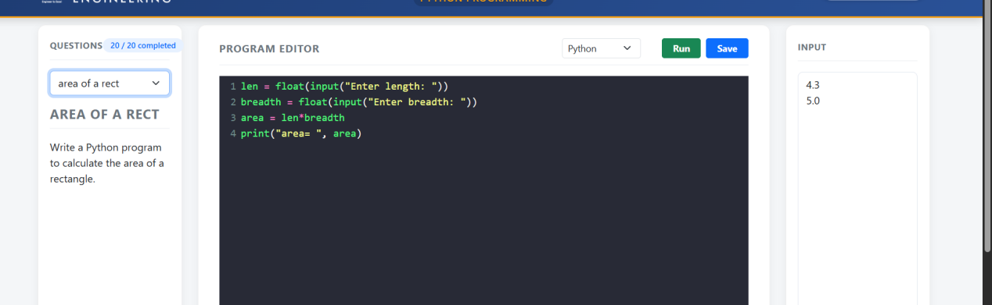

- Area of triangle

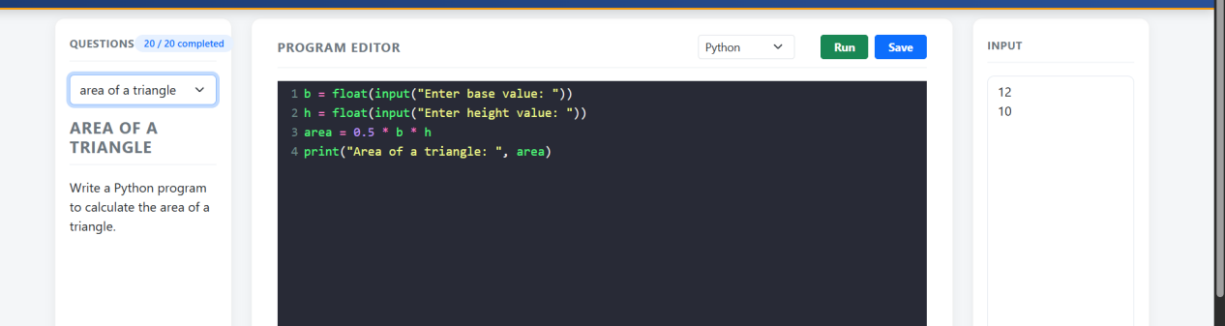

32.Circumference
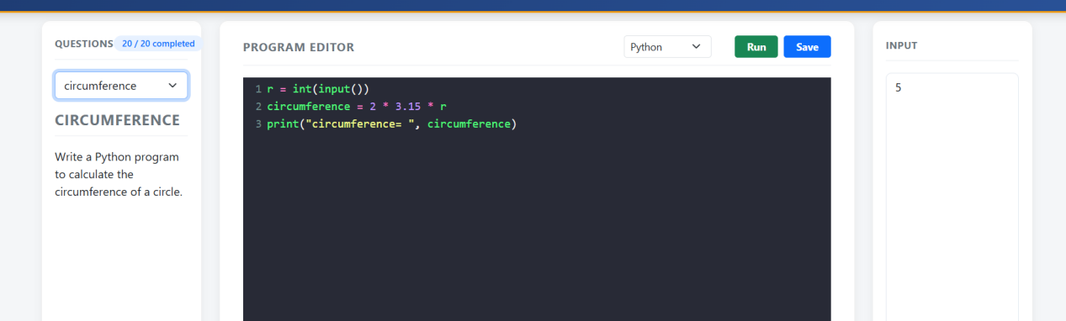

33.ascending order
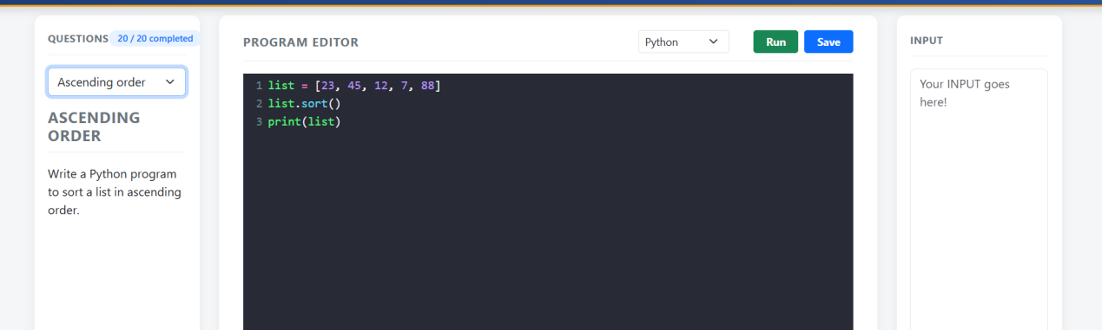

34.Negative or zero
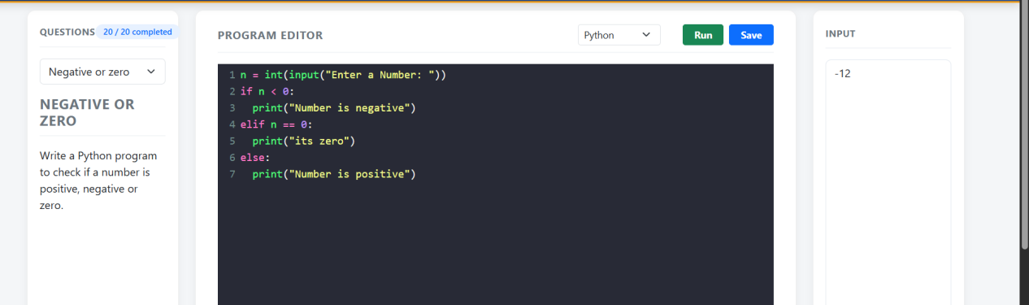

35.leap year
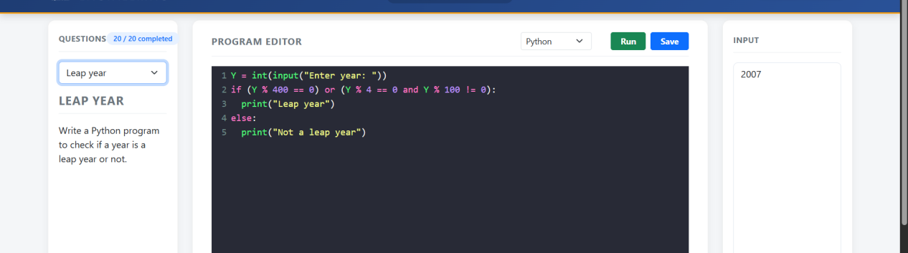

36.Divisible by 3 or 5
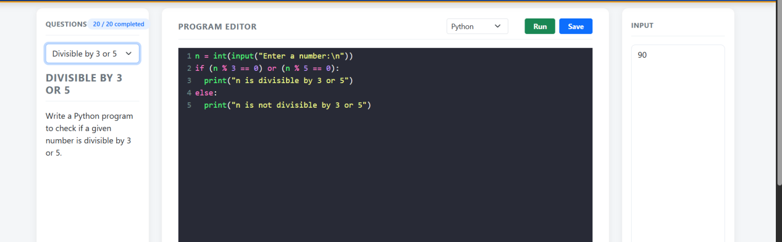

37.Vows or Cons
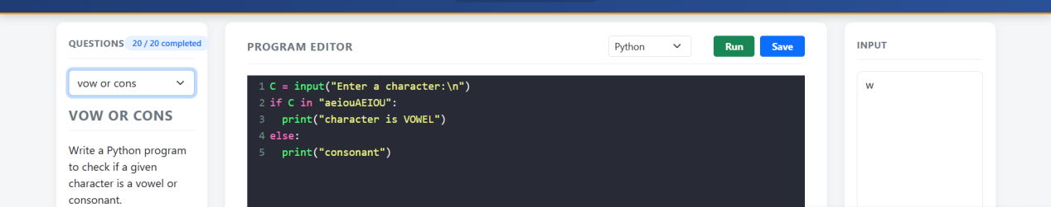

38.Valid email
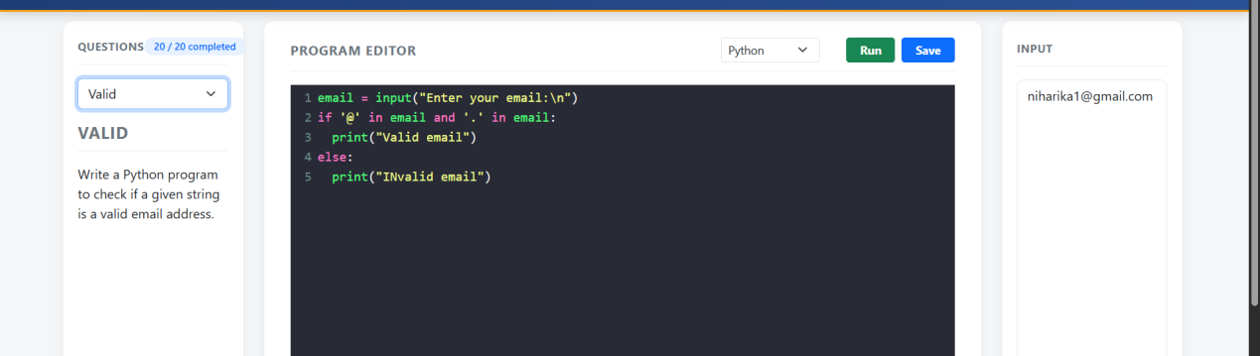

39.Sum even
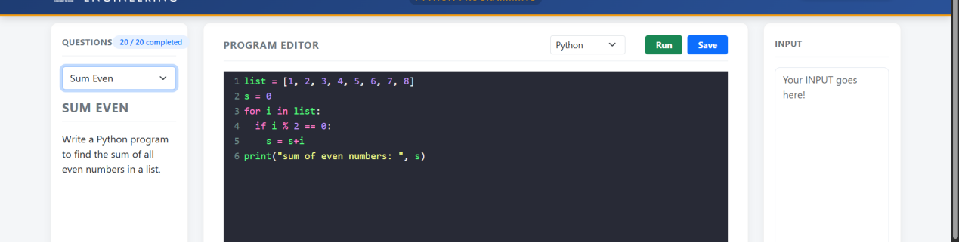

40.Sum odd
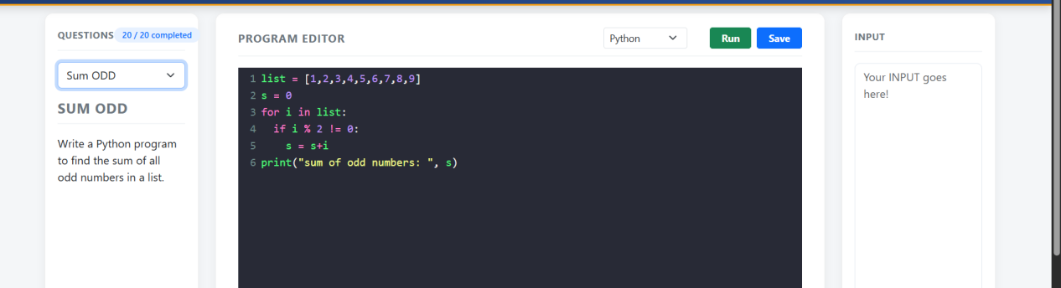

41.Average of numbers
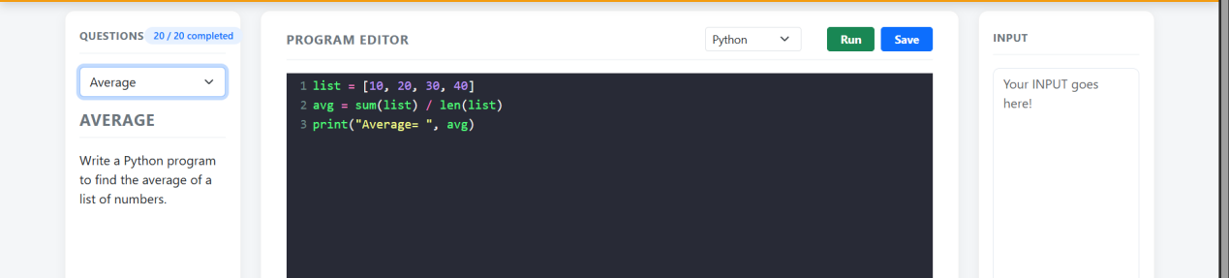

42.SQRT
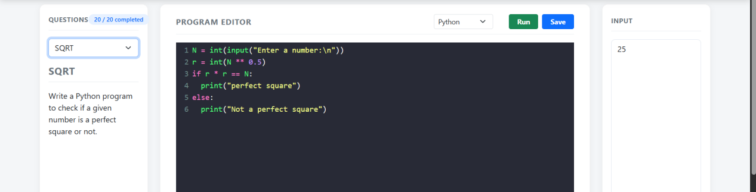

43.Max prime
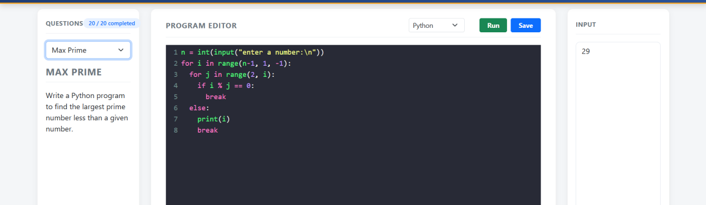

44.Quadratic Equation
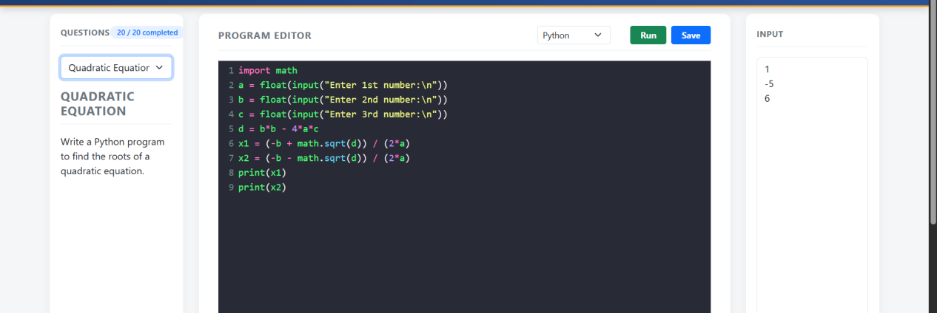

45.GCD of 3 numbers
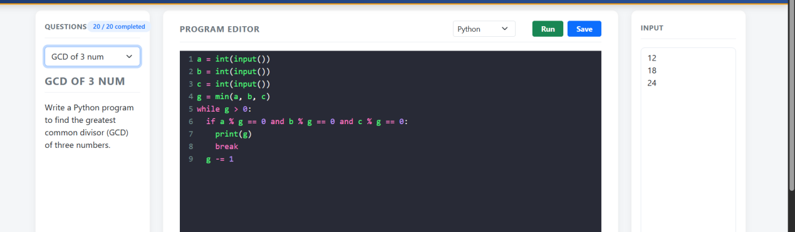

46.Valid password
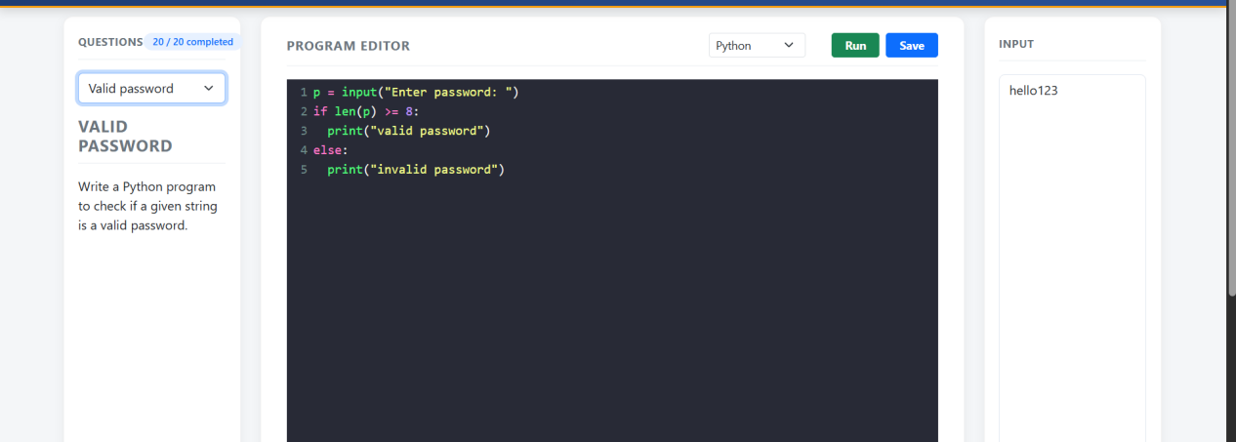

47.area of circle
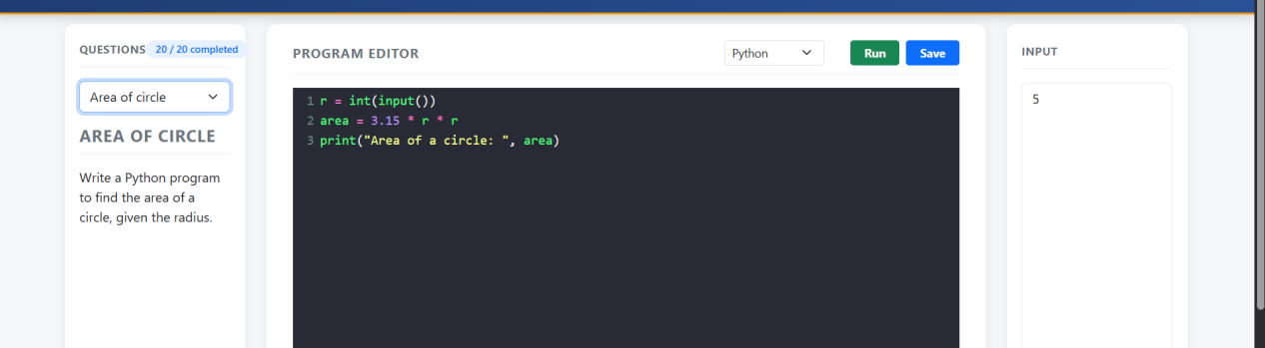

48.Print 1 to 10
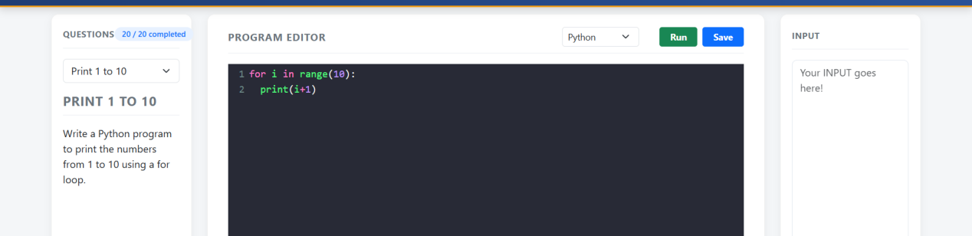

49.Multiplication table
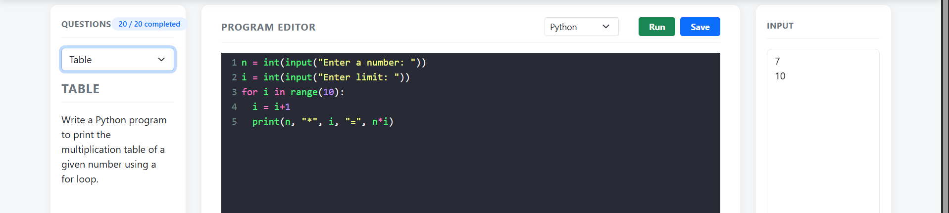

50.Sum of digits
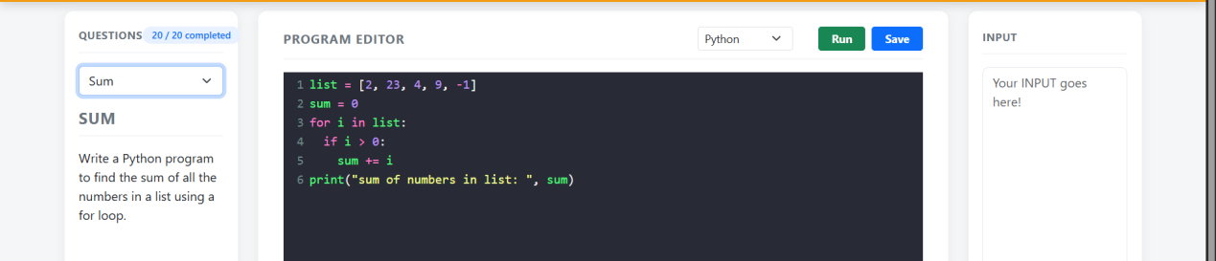

51.Fibonacci sequence
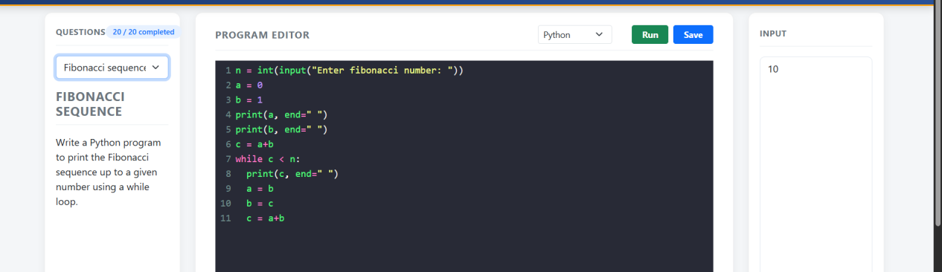

52.Sum while
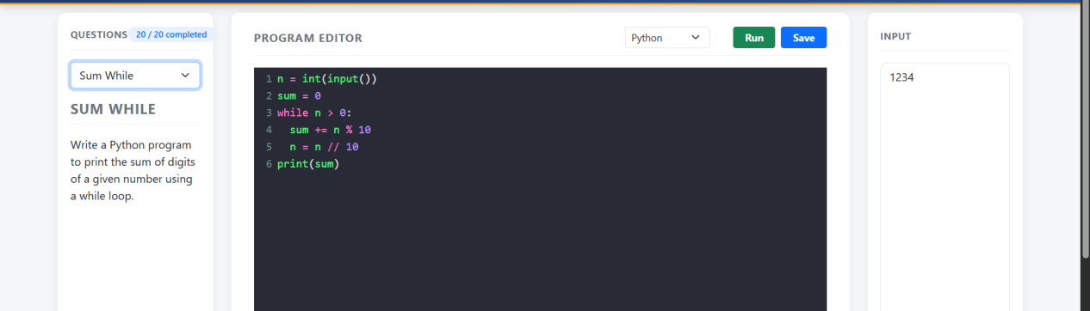

53.Count
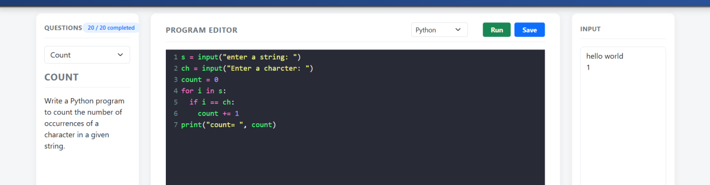

54.Slicing

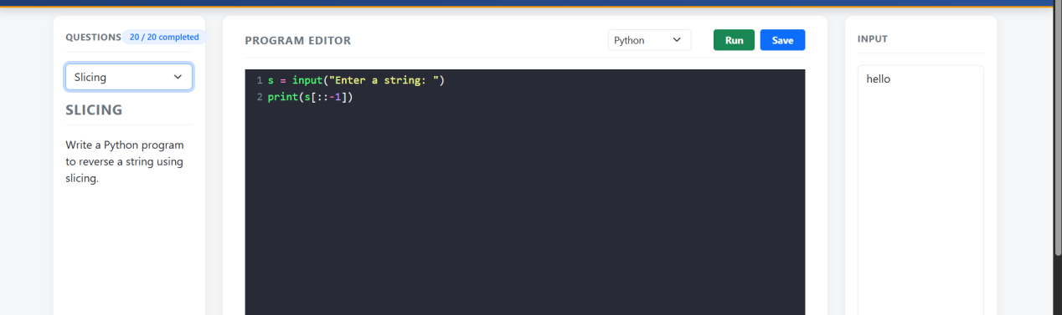

55.Palindrome-str
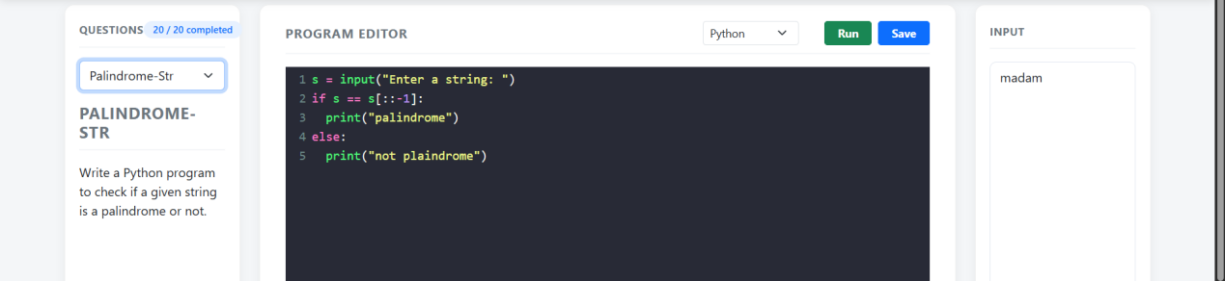

56.Captialize
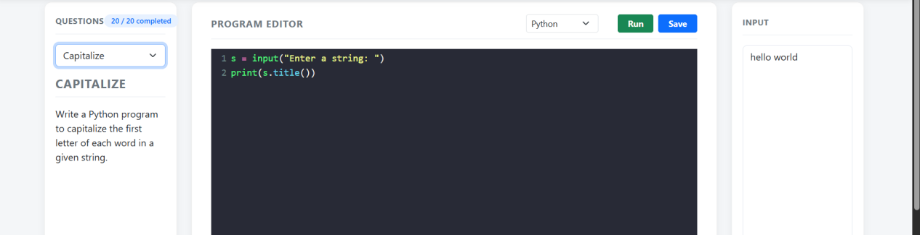

57.Length
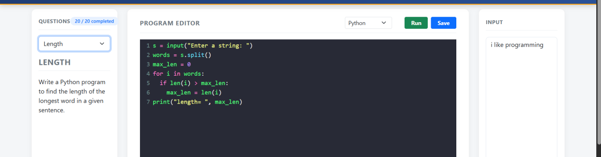

58.Operator
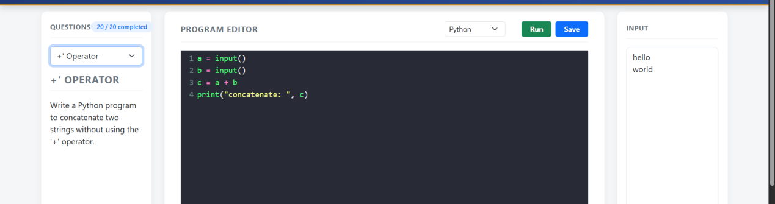

59.Remove vowels
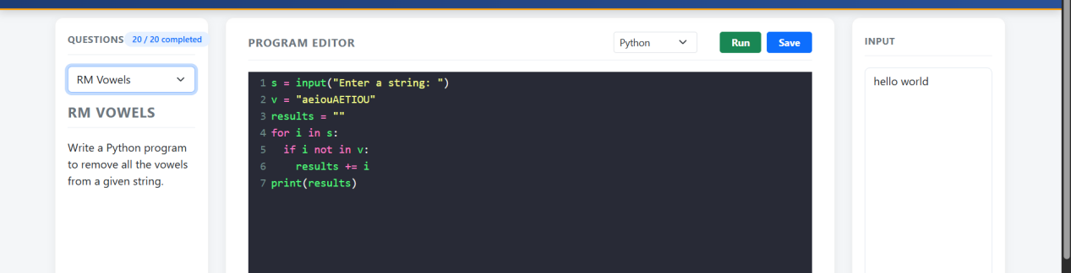

60.Digits
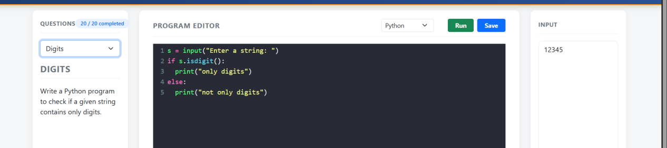

61.Frequent
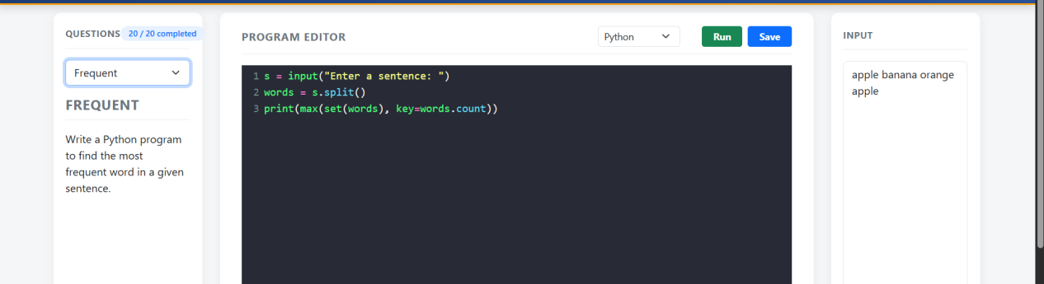

62.Replace Word
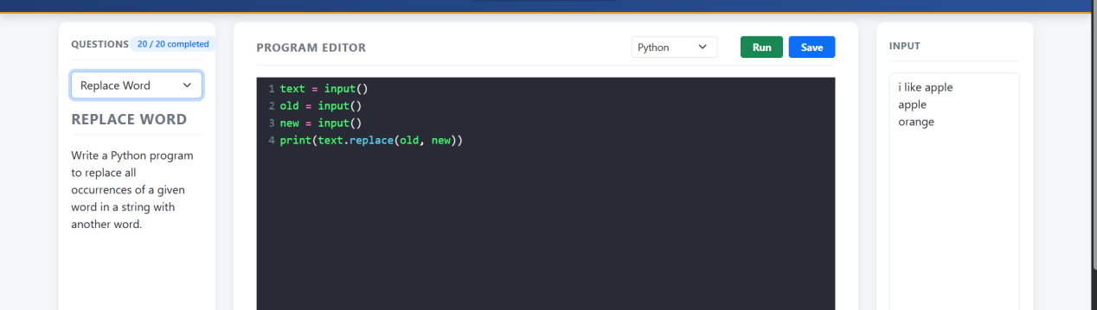

63.Non Repeating
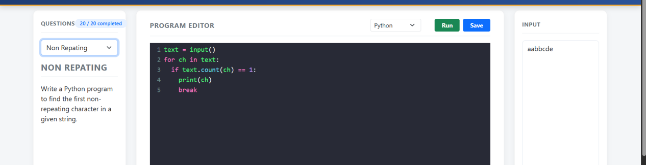

64.Anagram
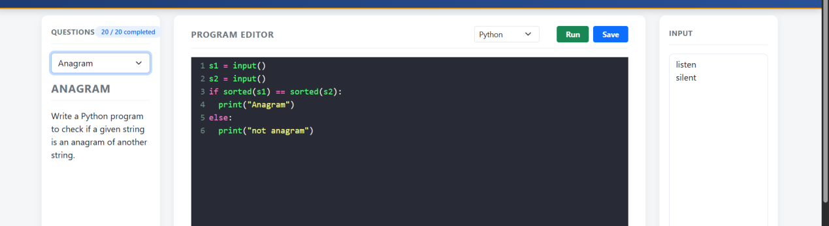

65.2nd Frequent
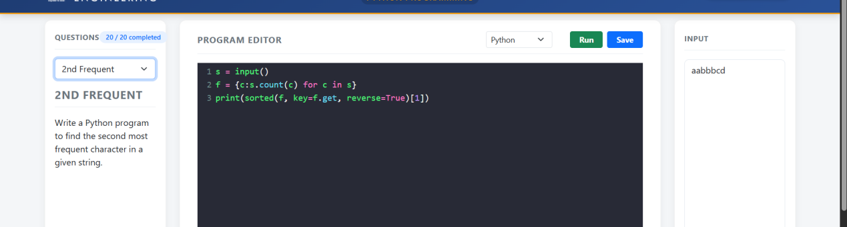

66.Common
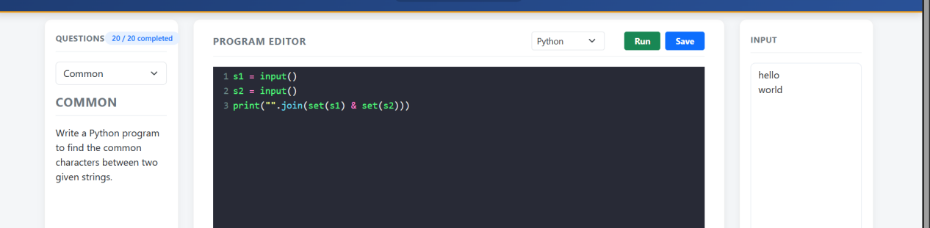

67.Remove whitespace
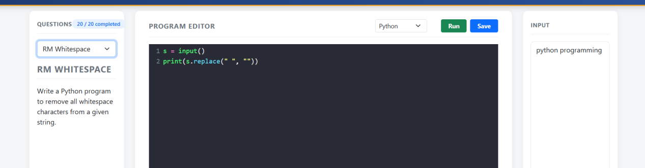

68.Substring
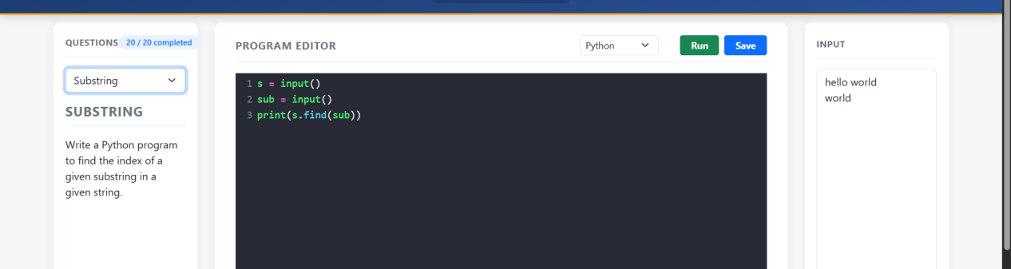

69.substring
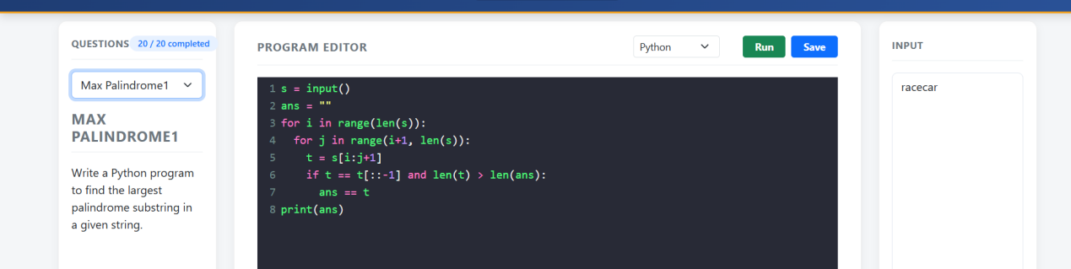

70.Count Words
